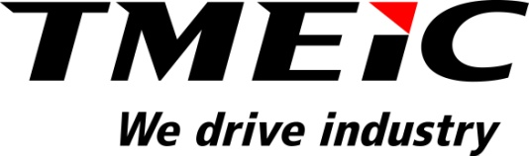

Media Contact

Keith Munson
Channel Partner Manager

p. 682-309-1433

e. keith.munson@tmeic.com

FOR IMMEDIATE RELEASE

TMEIC Strengthens Customer Development in Southern California

Allen Power Distribution and Control joins authorized channel partner network.

ROANOKE, Va. (August 14, 2017) – Toshiba Mitsubishi-Electric Industrial Systems Corporation (TMEIC) is pleased to announce the addition of Allen Power Distribution and Control, Inc. (APDC) to our authorized channel partner network.

APDC joins TMEIC’s growing sales network responsible for advising industrial clients in the appropriate application, specification, evaluation and installation of medium voltage power conversion equipment. MV solutions include adjustable speed drives, VAR compensators and electrical rotating machinery, such as medium voltage induction and synchronous motors. Based in Oceanside, California, APDC will assist TMEIC’s sales efforts in southern California, including San Luis Obispo, Kern and San Bernardino counties.

“We are excited to add Allen Power to our network of authorized sales representatives, as they bring a wealth of working relationships with consulting engineers, municipalities, water districts, utilities and end users in Southern California,” said Keith Munson, Channel Partner Manager at TMEIC.

APDC, a woman-owned small business, is an electrical distribution equipment and solutions provider with more than a decade of experience serving commercial, industrial and utility markets. To learn more about Allen Power visit www.allenpowerdc.com.

###

About Toshiba Mitsubishi-Electric Industrial Systems Corporation (TMEIC)
Toshiba Mitsubishi-Electric Industrial Systems Corporation (TMEIC) was formed in 2003 following the merger of the industrial systems departments of Toshiba Corporation and Mitsubishi Electric Corporation. TMEIC manufactures and sells variable frequency drives, motors, photovoltaic inverters and advanced automation systems for a range of industrial applications. We drive industry.

The North American operation –
TMEIC Corporation, headquartered in Roanoke, VA, designs, develops and engineers advanced automation, large AC and DC motors, photovoltaic inverters and variable frequency drive systems. TMEIC Corporation specializes in the Renewable Energy, Metals, Material Handling, Oil & Gas, Mining, Paper, Testing and other industrial markets worldwide. We drive industry. www.tmeic.com

