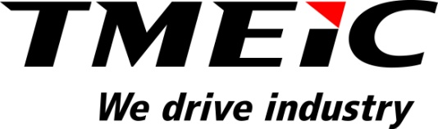

FOR IMMEDIATE RELEASE

TMEIC Houston and Katy, Texas Facilities update after Hurricane Harvey

TMEIC’s factories in the Houston area were not physically affected by the storm.

ROANOKE, Va. (September 5, 2017) – Toshiba Mitsubishi-Electric Industrial Systems Corporation (TMEIC) is an active member of the Houston community and we are deeply committed to the safety and wellbeing of our Houston area employees, friends and families. With the protection of our employees in mind, TMEIC factories in Houston and Katy, Texas were closed while the hurricane made landfall. Neither facility was physically impacted by Hurricane Harvey. We have resumed production of medium voltage drives and photovoltaic inverters. We are working closely with suppliers affected by Harvey to devise alternate plans to lessen the impact on our delivery schedules.

Our hearts go out to our community and the families who were devastated by Hurricane Harvey.

###

About Toshiba Mitsubishi-Electric Industrial Systems Corporation (TMEIC)
Toshiba Mitsubishi-Electric Industrial Systems Corporation (TMEIC) was formed in 2003 following the merger of the industrial systems departments of Toshiba Corporation and Mitsubishi Electric Corporation. TMEIC manufactures and sells variable frequency drives, motors, photovoltaic inverters and advanced automation systems for a range of industrial applications. We drive industry.

The North American operation –
TMEIC Corporation, headquartered in Roanoke, VA, designs, develops and engineers advanced automation, large AC and DC motors, photovoltaic inverters and variable frequency drive systems. TMEIC Corporation specializes in the Renewable Energy, Metals, Material Handling, Oil & Gas, Mining, Paper, Testing and other industrial markets worldwide. We drive industry. www.tmeic.com

Media contact: Crystal von Beck, Marketing Manager, crystal.vonbeck@tmeic.com

