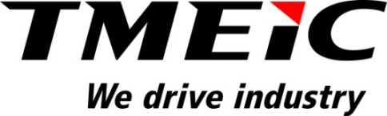

FOR IMMEDIATE RELEASE
Inauguration of Cold Rolling Mill II Complex at JSW Steel Limited
Roanoke, Virginia, December 31, 2014 –JSW Steel’s new greenfield cold rolling mill at the Vijayanagar works was inaugurated on April 25, 2014 by the Chairman, Sajjan Jindal.
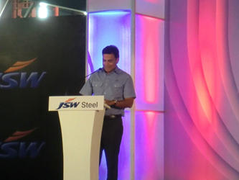
Sajjan Jindal at the inauguration ceremony
JSW’s new Cold Rolling Mill (CRM II) provides the most advanced automotive grade steel to Indian car makers. It is the largest and first of its kind in India, and has the capability to produce high strength and advanced high strength steels in both the cold rolled and coated categories. The Cold Mill, Continuous Annealing Line, and Continuous Galvanizing Line use state-of-the-art technologies, incorporated in the TMEIC process automation and control system. TMEIC supplied the complete electrical equipment for the mills and process lines including TMEIC motors, drives, automation hardware, and process sensors.
The important statistics for the new mill are summarized here:
Mill Equipment Production Capability
Pickle Line-Tandem Cold Mill 2.3 Million ton/year
Continuous Galvanizing Line 0.4 Million ton/year
Continuous Annealing Line 0.95 Million ton/year each line (2)

The five-stand tandem cold mill is shown below.
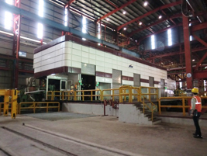
Five-stand Tandem Cold Mill
The inauguration ceremony was attended by representatives of the major equipment suppliers, including TMEIC (Japan), TMEIC Corporation (USA), TMEIC India (India), SMS, SPCO, and Donbang. Naotada Sawada, Executive VP of TMEIC, Dale Guidry, President and CEO of TMEIC Corporation, and Mr. Dahmen, President and CEO of SMS, were in attendance. In addition several large Indian automobile manufacturers who will be using JSW’s high grade steel were in attendance.

For more information about TMEIC’s mill automation systems, please contact Pankaj Mody at
pankaj.mody@tmeic.com Phone: 540-529-5142.

###
About Toshiba Mitsubishi-Electric Industrial Systems Corporation (TMEIC)
Toshiba Mitsubishi-Electric Industrial Systems Corporation (TMEIC) was formed in 2003 from the merger of the industrial systems departments of Toshiba Corporation and Mitsubishi Electric Corporation. TMEIC manufactures and sells variable frequency drives, motors, and advanced automation systems for a range of industrial applications. We drive industry.

The North American operation –
TMEIC Corporation, headquartered in Roanoke, VA, designs, develops and engineers advanced automation, large AC machines and variable frequency drive systems. TMEIC Corporation specializes in the Metals, Material Handling, Oil & Gas, Mining, Testing and other industrial markets worldwide. We drive industry. www.tmeic.com

