TMEIC Releases Videos
of Interview with Indian Economic Newspaper mint
– Corporate Brand Promotion to Further Enhance Company’s Presence in India and Globally –

Toshiba Mitsubishi-Electric Industrial Systems Corporation (hereinafter, “TMEIC”; President & CEO Masahiko Yamawaki) has released two videos featuring interviews with TMEIC President Masahiko Yamawaki and Managing Director Hemant Joshi of TMEIC Industrial Systems India Private Limited (hereinafter, “TMEIC India”). The videos entitled “TMEIC BUSINESS TALK with mint” developed at this time were taken during an interview session with the Indian daily economic newspaper mint as part of TMEIC’s initiatives in promoting branding activities to enhance its presence in India and globally.

TMEIC has been developing global brand promotion activities since March 2019 with a primary focus on India as a means of further gaining recognition and enhancing its presence in India and globally. The current videos have been produced in line with TMEIC’s advertorial for mint, which was published in the newspaper’s Delhi and Mumbai editions on November 6 and posted on Livemint for a three-month period from November 7.

In the video, President Yamawak provides a brief introduction to TMEIC and its business strategy as well as the key areas that TMEIC is promoting as a Group. He also conveys his message and high expectations toward the Indian market going forward. Managing Director Hemant Joshi speaks about TMEIC’s business strategy in India and provides insights to how TMEIC India is leveraging TMEIC expertise originating from Japan in high-end industrial applications such as steel rolling mills, container cranes automation, process systems, product development and software engineering.

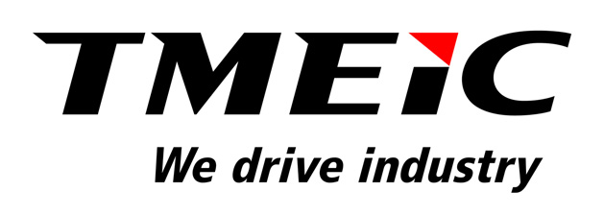 | 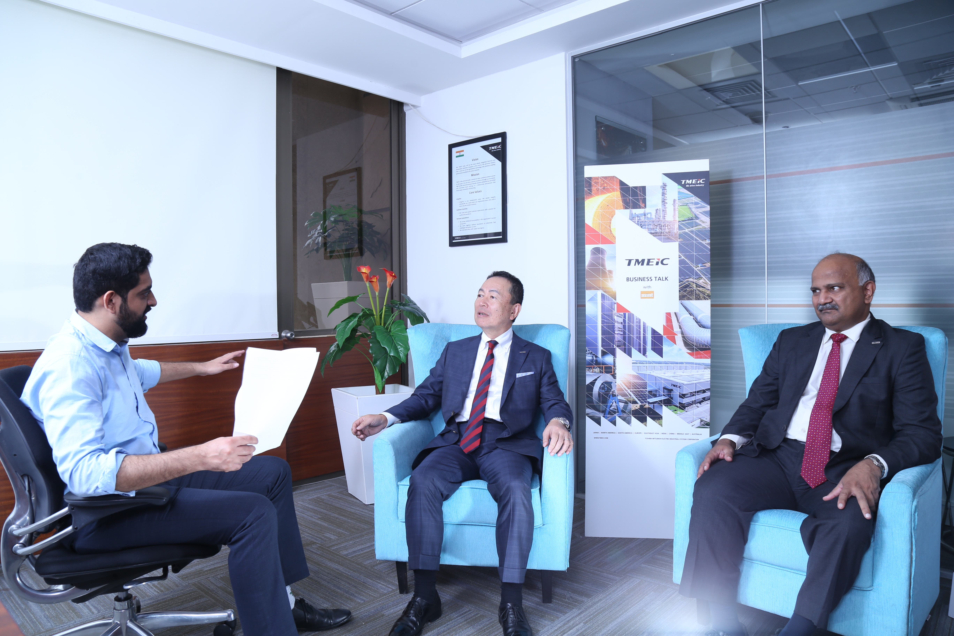
Interview session with mint (left to right):
Interviewer, TMEIC President Masahiko Yamawaki and
TMEIC India Managing Director Hemant Joshi
The videos are available at the following websites.
TMEIC Website:
TMEIC President Masahiko Yamawaki:
https://www.tmeic.com/president-yamawak-provides-brief-introduction-tmeic
TMEIC India Managing Director Hemant Joshi:
http://www.tmeic.com/managing-director-hemant-joshi-speaks-about-tmeics-business-strategy-india
Livemint:
TMEIC President Masahiko Yamawaki:
https://www.livemint.com/brand-stories/committed-to-helping-india-develop-says-masahiko-yamawaki-of-tmeic-11573102228274.html
TMEIC India Managing Director Hemant Joshi:
https://www.livemint.com/brand-stories/focus-on-product-reliability-is-the-reason-behind-our-consumer-retention-tmeic-11573133128801.html

Media inquiries:
For further information, please contact the Corporate Branding Group, Corporate Planning Division, TMEIC.
Tokyo Square Garden, 1-1, Kyobashi 3-chome, Chuo-ku, Tokyo 104-0031, Japan
Tel: +81-3-3277-4319; Fax: +81-3-3277-4578
https://www.tmeic.co.jp/

In order to respond to the needs of manufacturing sites that serve as a foundation for supporting society, TMEIC always sets its eyes on the future of industry, society and the environment as an industrial systems integrator striking a balance between the development of society and a beautiful global environment. TMEIC will contribute to manufacturing and environmental management through leading-edge technologies based on its core technologies of rotating machinery, power electronics and engineering.

